Growth for Digi-TextaGotchi-Mon

Growth happens in four major stages:

Egg –> Baby -> Adolescent - > Adult

**Egg Stage - 1 form**

Will, eventually, determine realm of the creature: Realistic (things based on real animals), Sci-Fi (robots, etc.), or Fantasy (dragons, elementals, etc.)

For now, we will just focus on Realistic Creatures so the egg should just look a normal egg you’d see in a game such as Pokemon.

Ex:

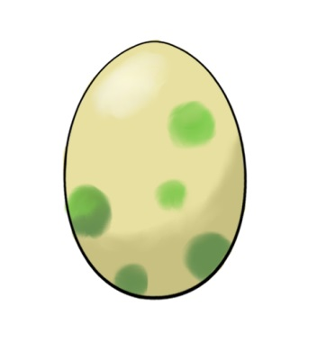

**Baby Stage – 4 forms**

Baby stage is where basic features of the creatures start to take shape. These 4 forms will be the same for **EVERY CREATURE EVER** (possibly different for the different realms).

“Baby” stage can more accurately be described as “Blob” stage, as these four forms should be non-descriptive blobs that, I don’t know, grow a stub each form. Whatever. Just make them generic enough for every creature ever.

Ex:

Form 1 Form 2 Form 3 Form 4

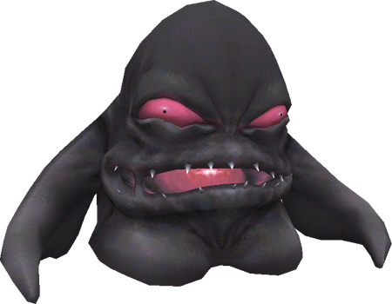

**Adolescent Stage – 4 Forms**

The evolution from Baby to Adolescent stage should be the biggest jump for the player as their creature will become the basic form that they will be growing off of from then on. The first stage is where the creature’s basic form is assigned (based on gameplay factors). E.g. in the realistic tree, the first form would be like a basic kitty, baby armadillo, or a monkey.

As the creature progresses through the adolescent stage, it will gain new features based on what kind of gameplay stats it has. For example, a Cat that is particularly fast will become a Cheetah, whereas one that is particularly strong will be a Tiger, or one that is particularly defensive is like a Lion.

The second form should establish the baseline Attack/Defense/Speed form (fiercer, more bulky, lithe, etc.) the creature takes (Cat - > Tiger/Lion/Cheetah, for example).

The third form should add a feature based on stats (Horn/Claws for attack, Wings/More Legs for speed, armored skin/spikes for defense, etc.).

The fourth form should either add another/enhance a feature based on the stats at the time of the fourth form.

Ex: (for cat)

Form 1 Kitteh Form 2 Sturdy Form 3 Defense Form 4 Defense+Attack

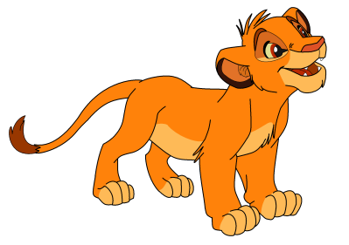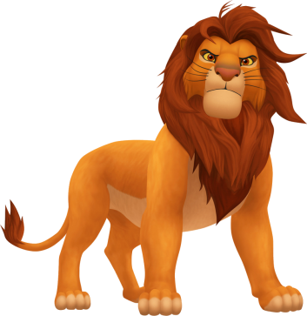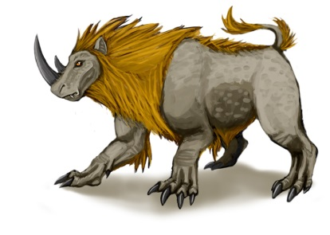

**Adult Stage - ? Forms (four?)**

This is the stage where the creature stops all pretenses and just takes consistent levels in badass. Basically the forms are set from here on out and shouldn’t change based on gameplay statistics aside from general growth points.

Ex: (from the cat example) (I gave up looking for images at this point)

